Meta Title:
Buyer representation services in Dubai | MAP Real Estate
Meta Description:
MAP Real Estate offers experienced Buyer representation services in Dubai designed to meet your diverse needs Schedule a virtual tour to close your deal.
Primary
Buyer representation services in Dubai | Expert buyer assistance in Dubai
Dubai Buyers Agent | buyer representation services
 | Real estate buyer representation Dubai
 | Experienced buyer representatives Dubai
 | Real Estate Purchase Representation UAE
Buyer agent services UAE.
Property Buyer Agents Dubai
Professional buyer Representation UAE
Dubai buyer agents for real estate
Property buying assistance Dubai
Experienced buyer representatives Dubai
Best buyer representation services in Dubai

Top Notch Buyer Representation Services in Dubai

We offer end-to-end Buyer representation services in Dubai and help people find their ideal property in Dubai. Through detailed experience in the Market evaluations and negotiating skills, we are always by your side starting from the moment of consultations, and ending up with additional assistance after the purchase.

Inquire Now!

Expert Buyer Assistance in Dubai Awaits You!

MAP Real Estate is an expert player when it comes to strategic marketing and visibility focus. Our buyer representation services focus on how institutions of higher learning can proactively market themselves and gain visibility in today’s increasingly competitive market. Moreover, we craft pricing strategies and unique promoted marketing plans for our clients to get maximum visibility in finding properties for your search. Our expert Dubai Buyers Agents assist in every phase of the bargaining process.

Professional Bargaining and Efficient Sale | Comprehensive Market Analysis
Our experienced buyer representation services agents apply negotiation expertise to ensure favorable agreements in the real estate for your feasibility. All parties are represented, so we facilitate more effective closings. | Our Real estate buyer representation Dubai agents also analyze the market, studying sales, price, and other characteristics, including historical experience and future expectations concerning the choice of target properties.

Schedule a Consultation Today!

Experienced the Best Buyer Representation Services in Dubai:
As experienced and seasonal real estate purchase representation UAE agents, our team will take care of every stage of representation. From starting the initial consultation to closing up the deal, our agents back you at every stage of the buying journey.
Consultation | Market Analysis | Property Search
Our first step involves identifying the appearance attributes, prices, and the period you are willing to take in the purchase. The ability, as the best, to adjust our services according to your preferences is made possible by outlining the expectations. | Our Property buying assistance Dubai agents use updated data, competitors' rates, and analysis tools to carry out area-specific market analyses as to pricing, absorption rates, etc. to disclose potential deals. | We pull out a selection of properties matching your requirements from MLS listings and our inventory. We also use the services of others such as G1 Real Estate for further property search and identification.
Property Viewings | Negotiation | Due Diligence
We arrange and attend viewings of options selected and are familiar with the main shortlisted choices. Because of insider working knowledge of the industry, we assist you in determining what appears appropriate. | By realizing win-win negotiations, our Property Buyer Agents in Dubai attain the highest value for money of the desired property using services from companies such as Transworld CRE for assistance in Business purchase negotiations. | Before closing our Professional buyer representation UAE agents help you appraise title records, disclosure statements, covenants, conditions and restrictions, inspection reports, and much more to ensure you are getting what you paid for.
Closing Process | Financing Guidance | Post-Closing Support
Interested clients secure closing- documentation, payments, and other details/ complications that are under our direct administration. Moreover, our Buyer agent services UAE agents also possess deal structuring and negotiation expertise. | Our Dubai buyer agents for real estate also introduce the sources of funds and assist with the preparation of applications to enable you to obtain the best terms for Financing options following your possible financial standing and the characteristics of the purchase. | After purchase, we accompany clients by answering any possible questions and suggesting contractors for renovation, property managers, or buyers/sellers of properties. Moreover, also provides individual investment services and virtually conducted tours.

Contract Preparation
In the end, our Experienced buyer representatives in Dubai also help to draft out an enhanced sales contract more protective of your interests when signing.

Our Strategic Result-Driven Approach:
Strategic | Responsive | Connected | Transparent
We have a systematic view where we aim at finding perfect locations with reasonable prices by recommendations and bargaining given research suggestions. | Responding quickly to new listings and opportunities gives us a better shot at competing with other offers in the fast-moving market of Dubai. | We know that our exclusive client base of brokers, developers, and private sellers means we have early input to options before the market does. | In terms of transparency and conflicts of interest, we offer low prices, and explain steps and relations – you can be sure we defend your position.

Why Choose Us

Industry Experience | Exclusive Buyer Focus | Comprehensive Advisory
Our licensed brokers relying upon first-hand complicated practice in dealing with the DAE property market secure buyer benefits in the closed property structure. | Since we are not combined listing agencies/buyer agencies we do not compromise buyer objectives as those agencies do. | To make sure the client makes an informed decision, we give consultations from the starting moments of choosing a product to the post-purchase phase.
Local Market Mastery | Tech-Powered Search | Seamless End-to-End Service
Being from Dubai, our brokers provide fine insight into sub-market conditions, important events, and relations that help find growth opportunities. | We use Digital tools for property selection and rely on indexation technology, print and online investigations as well as skilled agents to find the most attractive properties for you. | Our specialized teams handle all your acquisition processes for minimized hassle including viewings, negotiations, contracts, closing, and much, much more.

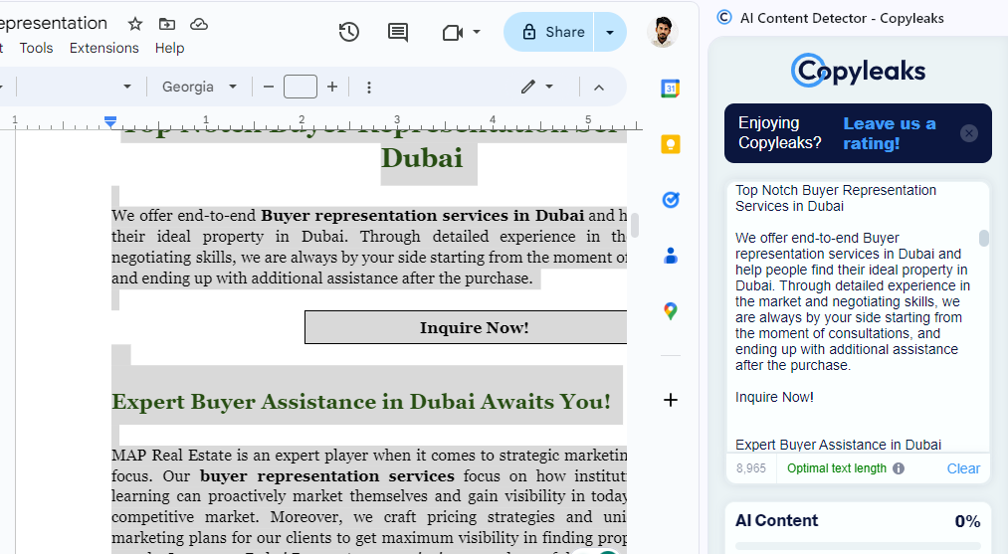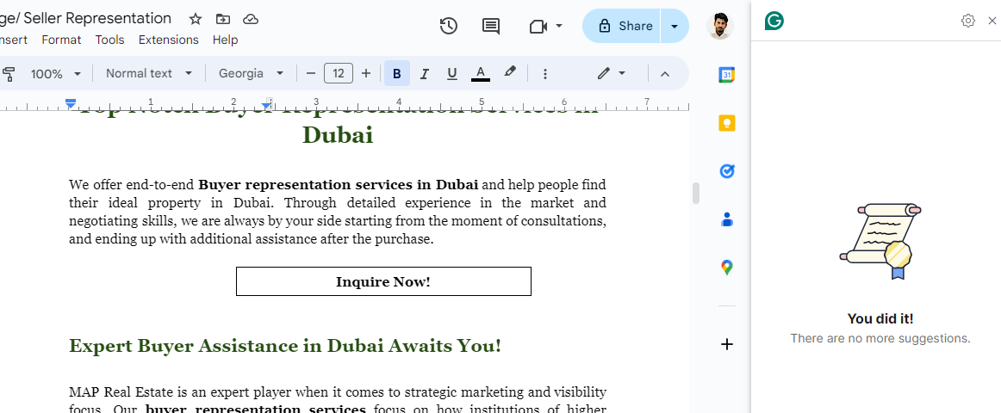

FAQ,s

What are buyer broker services?
Buyer brokers are licensed real estate professionals who only work on the side of the buyers and give advice on property purchases. Both are independent of the seller and the listing agent; they work for the buyer.

What does a buyer’s broker do?
A buyer’s broker coordinates your Business identification process, crafts Personalized investment strategies, and is your representative during your property search, viewings, negotiations, investigations, contract signing, mortgage helping, closing, and after-purchase services.

Are you tuned with certain developers in Dubai or a particular building?
No. As your exclusive buyer agents, we don’t have vested interests in any sectors and can use our relationships throughout the Dubai property market to identify opportunities relevant to your acquisition strategies for every major developer.

Will you be available to stand in for me even if I don’t intend to buy the property soon?
Yes. We constantly advise buyers from the original identification of targets to acquisition to the negation rounds and the closing and it may take several weeks, several months, or many months. Our guidance works with your time constraints.

Is there any fee involved when one does not buy a property?
No. Our buyer-broker fee is only earned after you first successfully make your way to closing on the property. Advisory costs have not been given directly to you if no purchase happens in the process of the services being offered to you.

Are you allowed to change the purchase order: the terms and conditions?
Absolutely. As your agents, it is our responsibility to bargain the price, conduct Market research, offer services and other Legal/Contractual guidance, and all aspects of the acquisition to safeguard your hard-earned cash and ensure you get the most advantageous deal on the market.

Are you in a position to source the deals and arrange viewings on off-market or in-pipeline properties?
Yes. Direct links with developers and agents enable us to explore other pipeline projects and opportunities before the going public goes out. Moreover, our International investment services also allow the clients early opportunities for selection.

Does MAP Real Estate Offer Seller Representation Services?
Yes, Of course, MAP Real Estate is a full-fledged real estate agency that also offers seller representation services to help its clients in Negotiation assistance, and Property Search and selection. If you need any kind of help related to selling or buying the property then you can Consultations with our brokers.

